Instructions for 35mm Mini Ferrocell Demonstration Unit

First, assemble the plastic cell phone stand by sliding supports over slotted edge of body (rough side of body is the top).

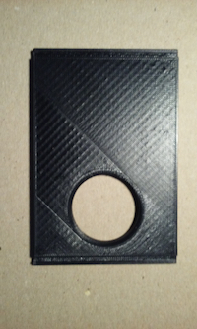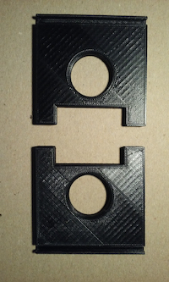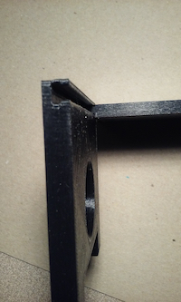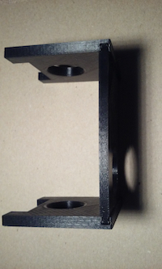

- Plug power adapter into main power outlet.
- Connect output plug from power adapter into jack coming from Ferrocell’s lighted base unit.
- Darken the room for viewing. Turn out all room lights if viewing at night.
- Place assembled stand over Ferrocell base unit and align top hole with base LED’s so there is no glare from the lights. A good alignment will form a white ring when facing straight down looking into the lighted base with minimum glare.
- Place cell phone camera over top hole and align the phone’s position to eliminate glare from the LED’s.
- Use the provided wands with magnets on their ends to begin your demonstration. One wand has a North pole on the end and the other wand has both North and South poles.
- Hold one wand in each hand while viewing their activity thru the cell phone camera.
- Move one magnet close to the center of the Ferrocell’s glass surface with one hand, and the other magnet near it with your other hand. You will see the flux bands bend and intermingle as the magnetic fields interact with each other. You will feel and see the difference between repulsion and attraction.
- You can use the camera zoom feature to see a larger image with more details.
- Be careful with these magnets! They are tiny but powerful and will crack if they slam together in attraction.
- You can record the action as a movie, or set your camera timer for that special shot.
- Alternately, you can use the Ferrocell base unit without the cell phone stand and just watch the action!

Warning. Do not leave magnets resting on Ferrocell glass surface for an extended time.
Do not use large or powerful magnets on this cell or you will damage it.
It is extremely sensitive and will resolve an applied magnetic field down to 100 Gauss.
Your Ferrocell has a 2-year warranty against defects. Warranty does not cover scratches, burns or dead-spots from the application of strong fields for extended periods of time.

